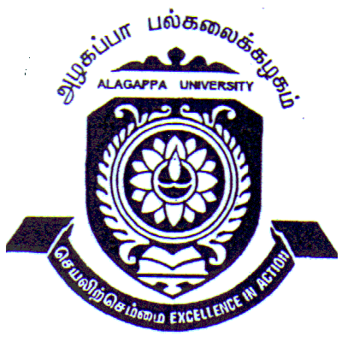 | ALAGAPPA UNIVERSITY, KARAIKUDI – 630 003  (A State University Established by the Government of Tamil Nadu  and recognized by UGC)  [Re-Accredited with ‘A’ Grade by NAAC] | 
NET/SET/GATE candidates are exempted from Entrance Examination
Notification for Pre-Registration Qualifying Entrance Examination for Ph.D. Program
(Written Test and Interview) August 2016

Eligible candidates desirous of pursuing Ph.D. Program (both FT/PT) in the University Departments, Constituent Colleges, Affiliated Colleges and other Approved Research Centres of Alagappa University are instructed to apply in the prescribed format for the Pre-Registration Qualifying Entrance Examination (Written test and Interview). Faculty-wise disciplines offered by the University are detailed below.

Faculty | Disciplines
Arts | 1.Tamil 2.English 3.Women’s Studies 4.Rural Development 5.History 6.Economics 7. Social Work 8. Fine Arts
Science | 1.Mathematics 2.Computer Science 3.Physics 4.Chemistry 5.Biotechnology 6.Molecular Biology 7.Microbiology 8.Nanoscience & Technology 9.Bioinformatics 10.Bioelectronics & Biosensors 11. Oceanography & Coastal Area Studies 12.Animal Health & Management 13.Zoology 14.Botany 15.Library & Information Science 16.Home Science 17.Geology 18.Energy Science
Management | 1.Management 2.Commerce 3.Corporate Secretaryship 4.Bank Management 5.International Business 6.Political Science
Education | 1. Education 2.Special Education & Rehabilitation Science 3.Physical Education

Eligibility Criteria | - Candidates who have passed through 10+2+3+2/11+1+3+2/10+3+2+2 pattern alone can apply  - P.G. Degree with 55% of marks, 50% marks for SC/ST / Physically or Visually challenged candidates, & 50% for P.G. qualified before 1st January 1991.  - M.Ed. (Education / Special Education) / M.A. Education is essential for Ph.D. in Education

Candidates who are in the final year / semester of their P.G. Degree may also apply for the Pre-Registration Qualifying Entrance Examination for Ph.D. Program. However the pass certificates will be issued only on production of attested copy of Cumulative Mark Statement ensuring minimum eligible percentage of marks in P.G. Degree

Application may be downloaded from the University website (www.alagappauniversity.ac.in). List of Approved Research Centres and discipline wise recognised Research Supervisors are available in the University Website. Filled in application must be accompanied by a DD for Rs.500/- drawn in favour of the Registrar, Alagappa University payable at Karaikudi.
Important Dates & Time
Purpose | Date | Time
Last date for receipt of filled in application | 05.08.2016 | 5.30 p.m.
Written Test | 28.08.2016 | 10.00 a.m. – 1.00 p.m.
Interview in the Concerned Department | 28.08.2016 | 2.00 p.m. onwards

For further details refer University website or contact the Recruitment Cell (Contact No.04565 – 223106). Late applications will not be entertained. University reserves the right to change anything mentioned above.

Karaikudi Dr. K. Uthayasuriyan Prof. V. Balachandran
16.06.2016 Special Officer (Recruitment Cell) Registrar i/c

